John Glenn School Corporation

Direct Deposit Authorization Form

Please print and complete ALL the information below.

Name: ____________________________________________________________

Address: ____________________________________________________________

City, State, Zip: ____________________________________________________________

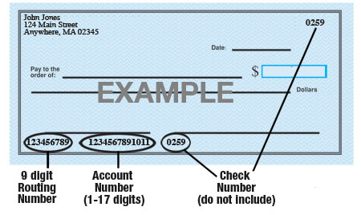

Name of Bank: ____________________________________________________________

9-Digit Routing #: ____________________________________________________________

Account #: ____________________________________________________________

Type of Account: Checking Savings (Circle One)

IF a checking account, please attach a voided check for the bank account to which funds should be deposited.

John Glenn School Corporation is hereby authorized to directly deposit my pay to the account listed above. This authorization will remain in effect until I modify or cancel it in writing.

Employee Signature: ____________________________________________________________

Date: ___________________________

